**Student Written Assessment (5TSD Deployment - Assignment)**

|  |  |  |  |
| --- | --- | --- | --- |
| **Business Unit/Work Group** | IT Studies | | |
| **Qualification Code** | National Code: ICT50715 TP000750 | **Qualification Title** | Diploma of Software Development |
| **Unit Code/s** | ICTPRG504 | **Unit Title/s** | Deploy an application to a production environment |
| **Assessment Task Title** | **5TSD Deployment Assignment** | | |
| **Student Name** | Submit your solution via your LEARN account | **Student SIS ID** | Submit your answers via your LEARN account |
| **Assessor Name** | You have been added to a LEARN group which defines your assessor. This is normally your Course Registration Number (CRN) lecturer. | **Date** | 2019 Semester 1 |

|  |  |
| --- | --- |
| **Student Guide for Practical Assessment** | |
| **Overview of Assessment** | This assessment will require you to complete nine sections requirements for Deployment Assignment. Each section has multiple parts require you to complete.  In this assessment you will cover the following topics:   * Plan a software installation * Perform the software installation * Plan and test an application removal * Perform the database installation * Manage an application configuration   The assessment is broken into 9 separate SECTIONS (SECTION A ~ I) and you will submit the solution by the assessment due date. There are some questions are team work and some questions are individual assessment. Students should make sure which question require you to participate as group work and/or individual work. |
| **Task/s to be assessed** | This part of the assignment requires you to use various deployment tools and do installation and uninstallation of the software applications into client computers. The following pages will define the specific tasks you need to complete. |
| **Time allowed** | You have the whole course duration to complete this exercise, however the assignment has its submission date. You should adhere to this date so that you get a balanced work load throughout the semester.  The submission date is provided in the LEARN course and summarized in the Assessment Submissions topic in LEARN. |
| **Location** | You can complete this assessment during your practical sessions and at home. |
| **Decision making rules** | To receive a satisfactory outcome for this assessment you must complete all tasks and parts correctly. |
| **Assessment conditions** | You must use the deployment tools such as ClickOnce, ThirdParty software like InstallShield and Wix in completing this assessment. |
| **Resources required** | None. |
| **Results/Re-assessment** | You will be provided feedback for each task of the assessment and be given the opportunity to resubmit with any required corrections only once. |
| **Submission Instructions** | The exercise can be found in the Assessment Submission Topic on LEARN. Your solution is required to upload to LEARN. |

**Deployment – Assignment**

***Assignment background:***

*Complete this assignment using the ClickOnce, InstallShield, Wix and also Windows Store. The assignment is a practical exercise which requires students to work together in a team development environment. Each group should have 3 team members (at most 4) . You should be working with the same group members from the previous assignment - Start_Finance_Assignment.*

*It focuses to give students with the following experiences:*

1. *Plan a software installation*
2. *Perform the software installation*
3. *Plan and test an application removal*
4. *Perform the database installation*
5. *Manage an application configuration*

*The class is divided into student groups.*

* *Each group should be no more than 3 (ideally) or 4 (at most) people in a group.*
* *Organise your group so that you have a group leader (administrator) and developer members.*
* *All students must participate the group submission tasks and each student also has individual task to fulfil the assignment requirements.*
* *There are student files are available from the Assessments section in LEARN.*
* *Other than submitting the final product on Moodle for marking. You need to demonstrate your deployment of the applications to the client site machine with your group work and your individual work.*
* *For submission on Moodle:*
* *You need to have screen shots to illustrate that you have completed all SECTION tasks. You are expected to have the Word document and label all images that you have captured.*
* *The group leader will upload the group work and individual member will upload their individual work to Moodle for marking. There are two different links for uploading (one for Group work & one for Individual work). To avoid the application too big in size to upload to Moodle, before you zip up the application files, you can delete the ~\obj and ~\bin folder since they are generated codes.*

**Scenario:**

ITWorks director has some applications need to be deployed to the client machines. Your team members are responsible to develop and deploy the applications to the client site.

Tasks:

## SECTION A. (Team work)

You are given with three applicatios:

* **Vendor Maintenance application**
* **Start_Finance application**
* **& Hotel_Management application**

and also the given the two client and server machines details. Note the client and server has the same configuration. You assume that every day, there is about 100 user transactions per day. Determine whether the target deployment computers meet the requirements or not.

1. For Vendor Maintenance application, the client site has a client computer and the database server computers.

|  |  |  |  |
| --- | --- | --- | --- |
|  | Recommended requirements to install the application | Assess development client and production Server – machine resource like hard disk/ memory/CPU etc. available | Assess whether it meets the installation requirement or not (**Yes/ No**). |
| Operating System platform & version | Windows Vista | Windows 10 1607 | Yes |
| Network (LAN or Web) | LAN and Web access | LAN and also available on Web access | Yes |
| Application type (Windows application, web application or mobile application) | Windows application | Windows application | Yes |
| Hard disk size(GB/MB) for installation | 5GB max | 1 TB free | Yes |
| RAM (GB/MB) for installation | 512MB | 8 GB | Yes |
| CPU type & requirements for installation | 1GHz processor | Intel i7 8700K with 6 cores CPU | Yes |

1. For Start_Finance application client server requirements:

|  |  |  |  |
| --- | --- | --- | --- |
|  | Recommended requirements to install the application | Assess developer and poduction mobile appliaction machine – resource like hard disk/ memory/CPU etc. available | Assess whether it meets the installation requirement or not (**Yes/ No**) |
| Operating System platform & version | Windows Vista | Windows 10 1607 | Yes |
| Network (LAN or Web) | LAN | LAN | Yes |
| Application type (Windows application, web application or mobile application) | Windows application | Windows application | Yes |
| Hard disk size(GB/MB) for installation | 5GB | 500 GB free | Yes |
| RAM (GB/MB) for installation | 512MB | 8 GB | Yes |
| CPU type & requirements for installation | 1GHz processor | Intel i5 5575R with 4 cores CPU | Yes |

1. Determine the installation methods for the three applications can be used.

|  |  |  |
| --- | --- | --- |
| Application | Which installation method(s) you are going to chose **(e.g. ClickOnce /Installed Shield/ Wix / Microsoft Store and/or other method)** | What is your reasons |
| Vendor Maintenance application | WIX | Application requires database hosted locally. WiX allows post-installation script to create the database in a MS-SQL instance. |
| Start Finance application | ClickOnce | Application stores data with SQLite, no DB instance required. ClickOnce also allows barebones version control. |
| Hotel Management application | WIX | Application requires database hosted locally. WiX allows post-installation script to create the database in a MS-SQL instance. |

## SECTION B. (Team work)

Determine the security requirements for deploying the application

|  |  |
| --- | --- |
| Application | Security required to deploy into the Client site/ machine  **Operating system – administrator right/ application/ application database admin./ certificates of the application’s publisher** – You are required to address **each** of the security requirements one by one |
| Vendor Maintenance application | Administrator rights: Yes  Application security: No  Application database rights: Read/Write/Alter  Publisher certificates: Yes |
| Start Finance application | Administrator rights: Yes  Application security: No  Application database rights: No  Publisher certificates: Yes |
| Hotel Management application | Administrator rights: Yes  Application security: Yes  Application database rights: Read/Write/Alter  Publisher certificates: Yes |

## SECTION C. (Team work)

Prepare an installation plan. (Template provided).

Use the provided Installation plan template (provided as student files), add details into the install plan for the deployment of the **Vendor Maintenance** application using Wix.

## SECTION D. (Individual work)

This is an individual task that each group member must use **one** of the following installation method that you have confirmed in class:

* ClickOnce for Vendor Maintenance application
* InstallShield for Vendor Maintenance application
* Wix for application with the database requirement for Vendor Maintenance application
* Start Finance application through Microsoft Store with side loading.

You need to create an **installation package** for the application such as **setup.exe, .msi, IIS**, **wix application project and app package.**

The installation package should include the application icon, organization name, pre-requisites, install path, license agreement and shortcut and GUID serial no if applicable. (Note: You must upload your application with the installtion package to Moodle for marking.)

## SECTION E. (Individual work)

1. Demonstrate the installation using the **installation package** generated from SECTION D in the **development machine**.

|  |  |
| --- | --- |
| **Installation Package included:** | **Check points achieved (Yes/No or N/A)** |
| Setup.exe, .msi, IIS, wix, project, app package |  |
| Organization name |  |
| Install path |  |
| Pre-requisites (OS version or download folder) |  |
| icon |  |
| Shortcut |  |
| Start menu |  |
| License agreement |  |
| GUID serial if applicable |  |

1. Demonstrate the installation using the installation package generated from SECTION D in the **production machine**. (e.g. For demonstration, you must be able to install in a different machine than your development machine.)

|  |  |
| --- | --- |
| **Installation Package included:** | **Check points achieved (Yes/No or N/A)** |
| Setup.exe, .msi, IIS, wix, project, app package |  |
| Organization name |  |
| Install path |  |
| Pre-requisites (OS version or download folder) |  |
| icon |  |
| Shortcut |  |
| Start menu |  |
| License agreement |  |
| GUID serial if applicable |  |

## SECTION F. (Individual work)

1. Create un-installation package on the **development machine.**

* For ClickOnce – use windows add/remove program since no uninstaller package available. You will need to demonstrate manually on add / remove the application through windows uninstaller, the app path and registry.
* For InstallShield – Include Repair/Remove and Uninstall options.
* For Wix application - add the uninstall shortcut to uninstall the application.
* For Windows UWP application – create the application package

1. Demonstrate the un-installation using the un-installation package generated from the **development machine**. (e.g. For demonstration, must unintall from the development machine only)

|  |  |
| --- | --- |
| **Successfully un-install the installed components such as:** | **Check points achieved (Yes/No or N/A)** |
| 1. Setup.exe, .msi, IIS, wix, project, app package |  |
| 1. icon |  |
| 1. Shortcut |  |
| 1. Start menu |  |
| 1. Installation folder |  |

Need screen shots to prove of successful completion for before and after the un-installation package is exceuted.

## SECTION G. (Individual work)

Demonstrate the uninstallation using the uninstallation package generated by the SECTION F in the **production machine**.

(Note: Other than showing to the lecturer that you have successfully completed it. You also capture the screen shots that the application has successfully done.)

For all ClickOnce , InstallShield, Wix & UWP, need to illustrate all install components will be removed.

## SECTION H. (Team work)

a. Create a Wix database project to deploy **the database** of the Vendor Maintenance application to the client site machine.

b. Demonstrate the Wix database deployment is successful. You need to illustrate the option of dropping an existing database on installation and on uninstallation issues.

Part A Development side:

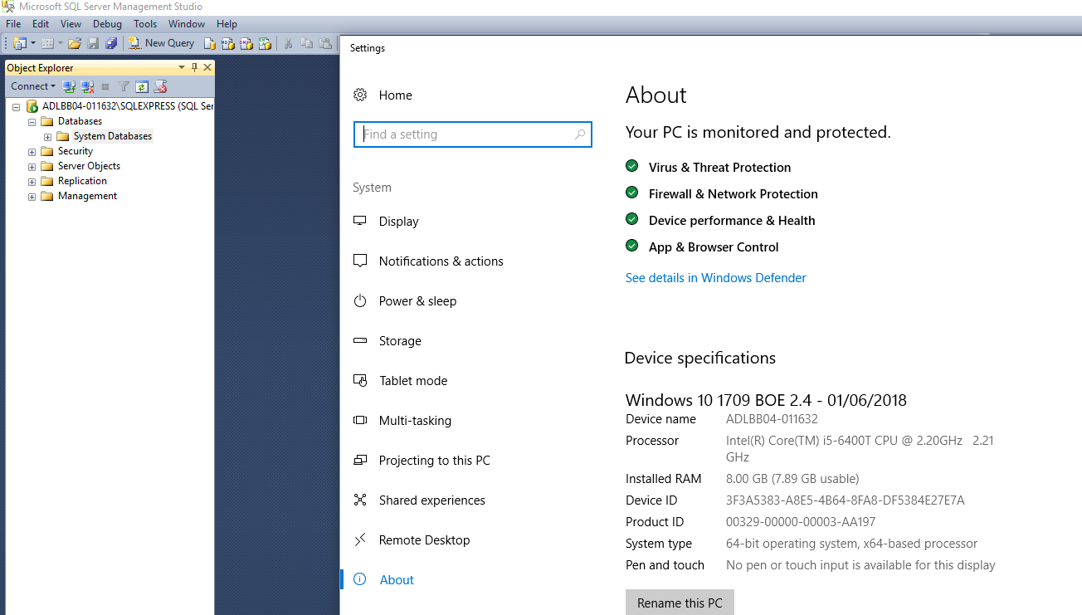

Figure : SQL service running without required database.

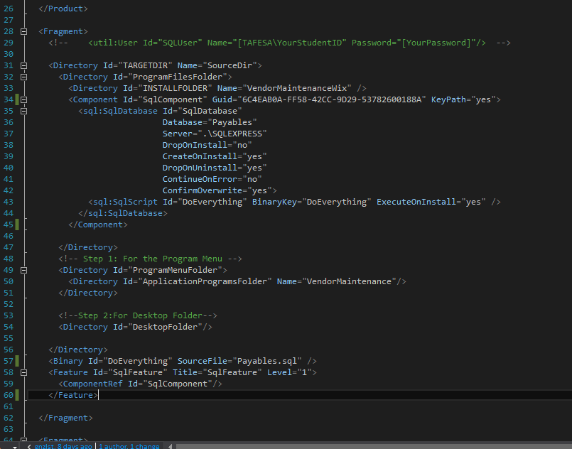

Figure : WiX XML configuration for creating/dropping DB.

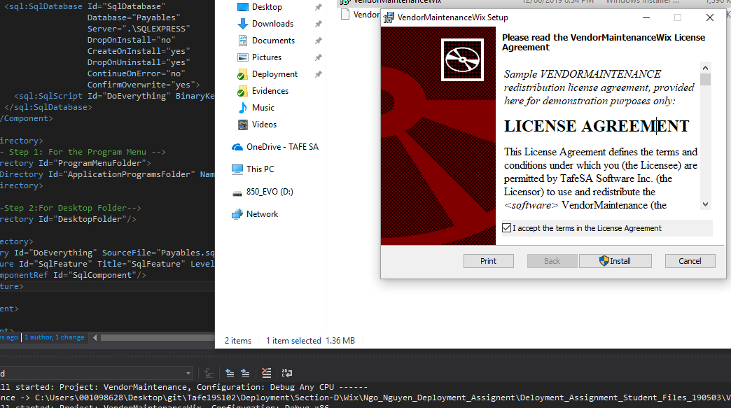

Figure : WiX installer running with EULA.

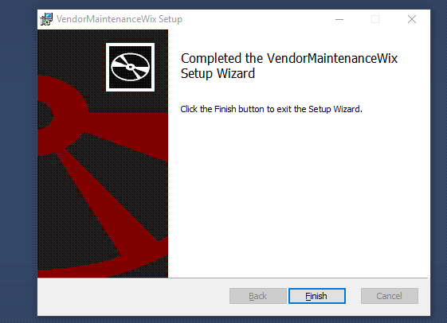

Figure : Installation successful.

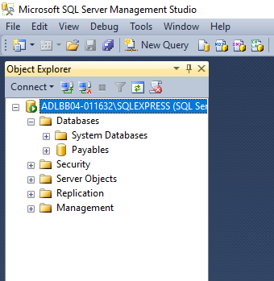

Figure : Database Payables can be seen in schema.

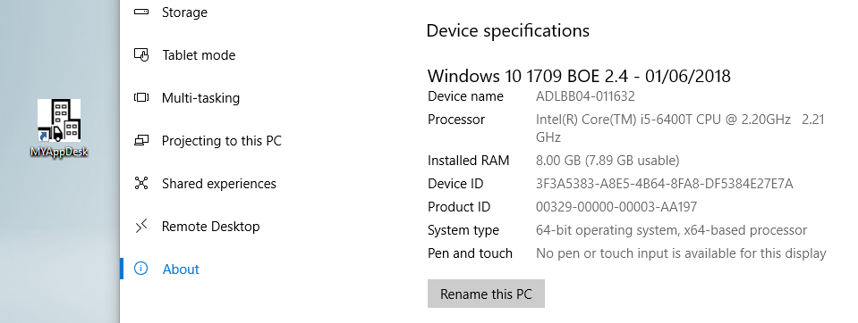

Figure : Desktop icon created on development machine.

Part A Client Side:

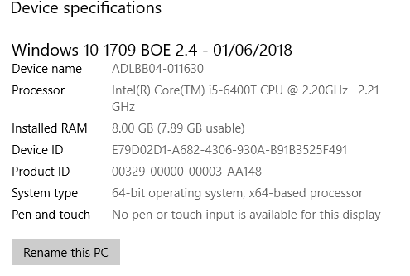

Figure : System information of client computer.

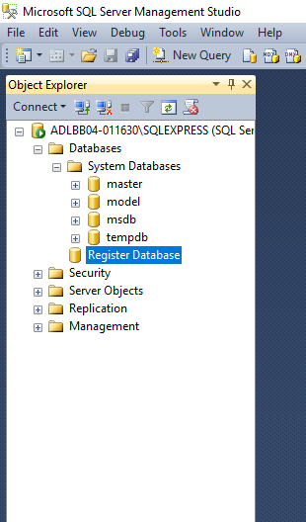

Figure : Client computer does not have instance of Payables.

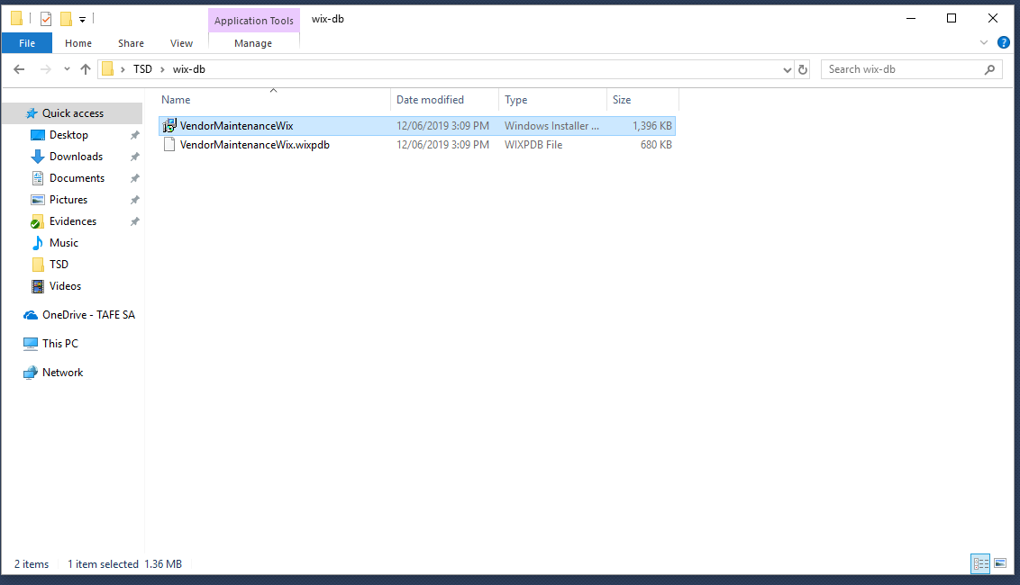

Figure : Running installer from client side.

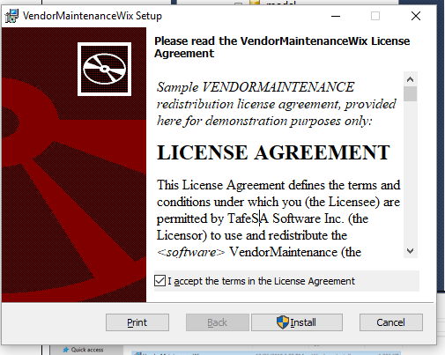

Figure : Installer working with EULA.

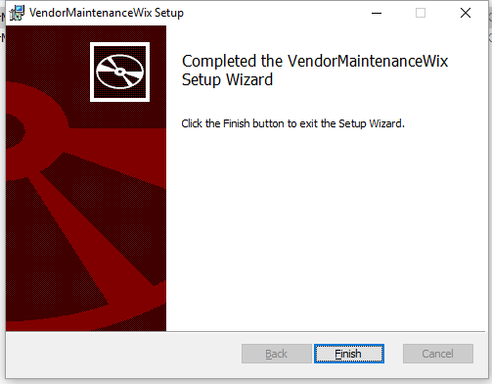

Figure : Installation completed successfully.

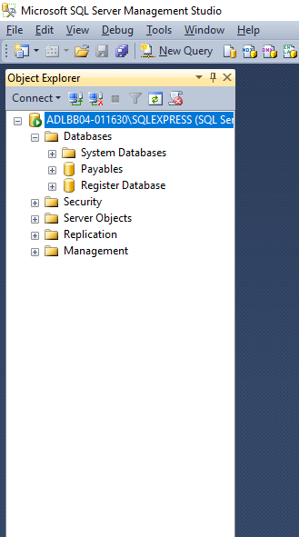

Figure : Client now has instance of Payables table.

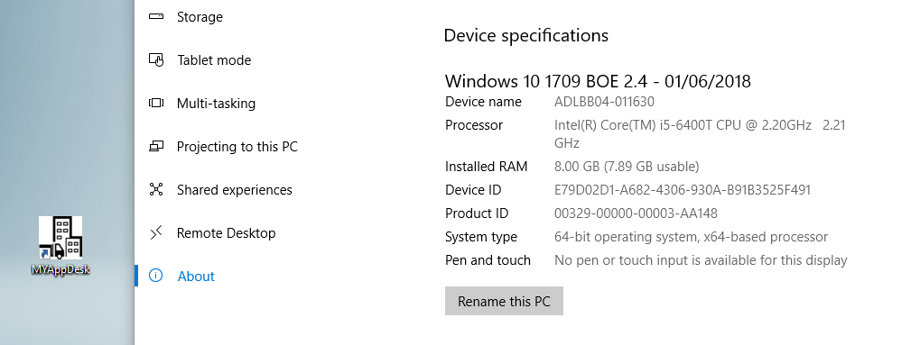

Figure : Desktop icon generated on client computer.

Part B Development Side:

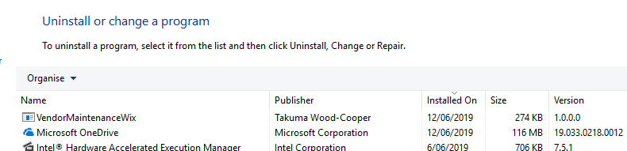

Figure : Uninstalling app.

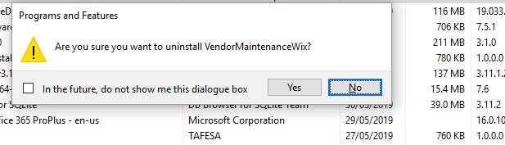

Figure : Confirmation for uninstallation.

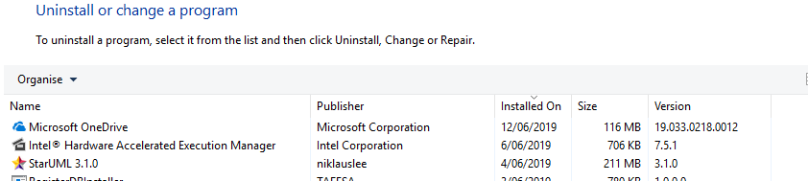

Figure : Application now missing from programs list.

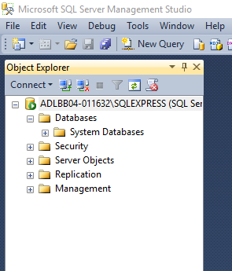

Figure : Database dropped on uninstallation.

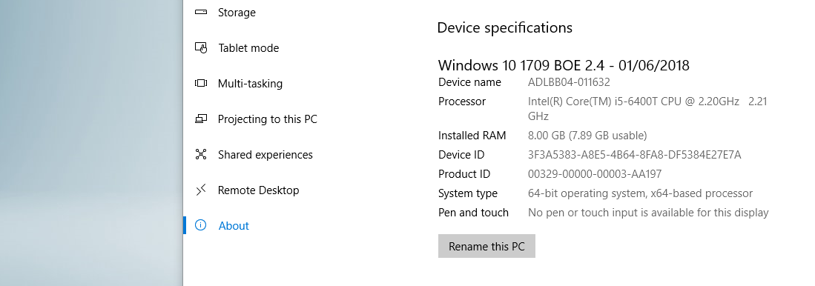

Figure : Desktop icon also removed from development machine.

Part B Client Side:

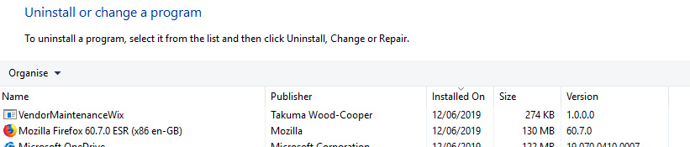

Figure : Uninstalling app from client machine.

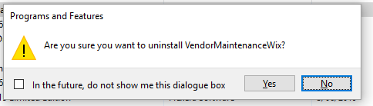

Figure : Confirmation for uninstallation.

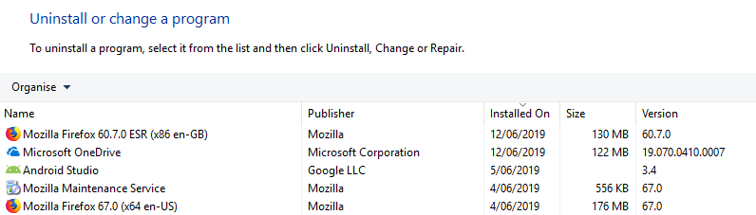

Figure : Application now missing from programs list.

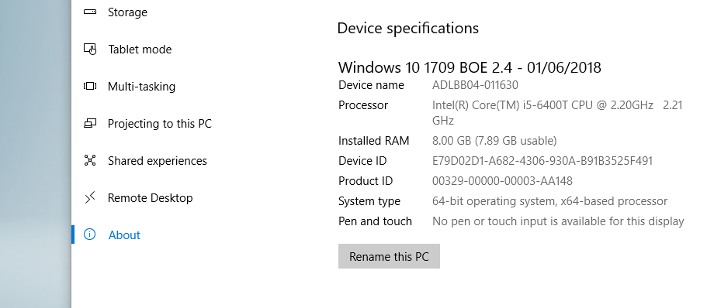

Figure : Desktop icon missing after uninstallation on client computer.

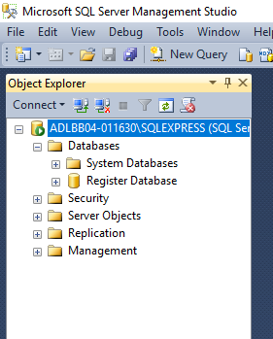

Figure : Database "Payables" no longer existing after uninstallation from client.

**Note: Make sure that you capture the screen shots for both part a & b for successful completion.

## SECTION I. (Team work)

1. Given the **Hotel_Management** application, the program is incomplete in the features but the database connection strings are hard coded the database location with the development machine directories. You are required to change the program codes so that it will use the **App.config** file to assign where the database files are located. In the program code, the database connection strings will be **parameterised** to reference the location of the database in the App.config file. At the moment, there are over 13 places of database connections are hard coded. After your modification, the change of the database locations will just need to change the App.config file only. (** You are required to demonstrate your changes so that the database connection is successful. Member to submit your program to Moodle for marking.)

**The Hotel Management application login info:

User Name**: admin**

Password**: admin**

User Name**: kitchen**

Password: **kitchen**

1. You need to deploy the **Hotel_Management** application to the production server and illustrate the change of the database locations without the change of the 23 connection strings by simply modifying the **App.config** file only.
2. In ClickOnce, if the application may require elevated permissions. For example, to enable debugging with **restricted permission**. If the user accepts, the application will be installed, otherwise the installation will be halted.

What option would you choose during publishing the ClickOnce application in order that the user will be prompted during installation to grant permission? (** Other than the demonstration, remember to **capture the screen shots** to show the options to prove that you have achieve this.)

Part B:

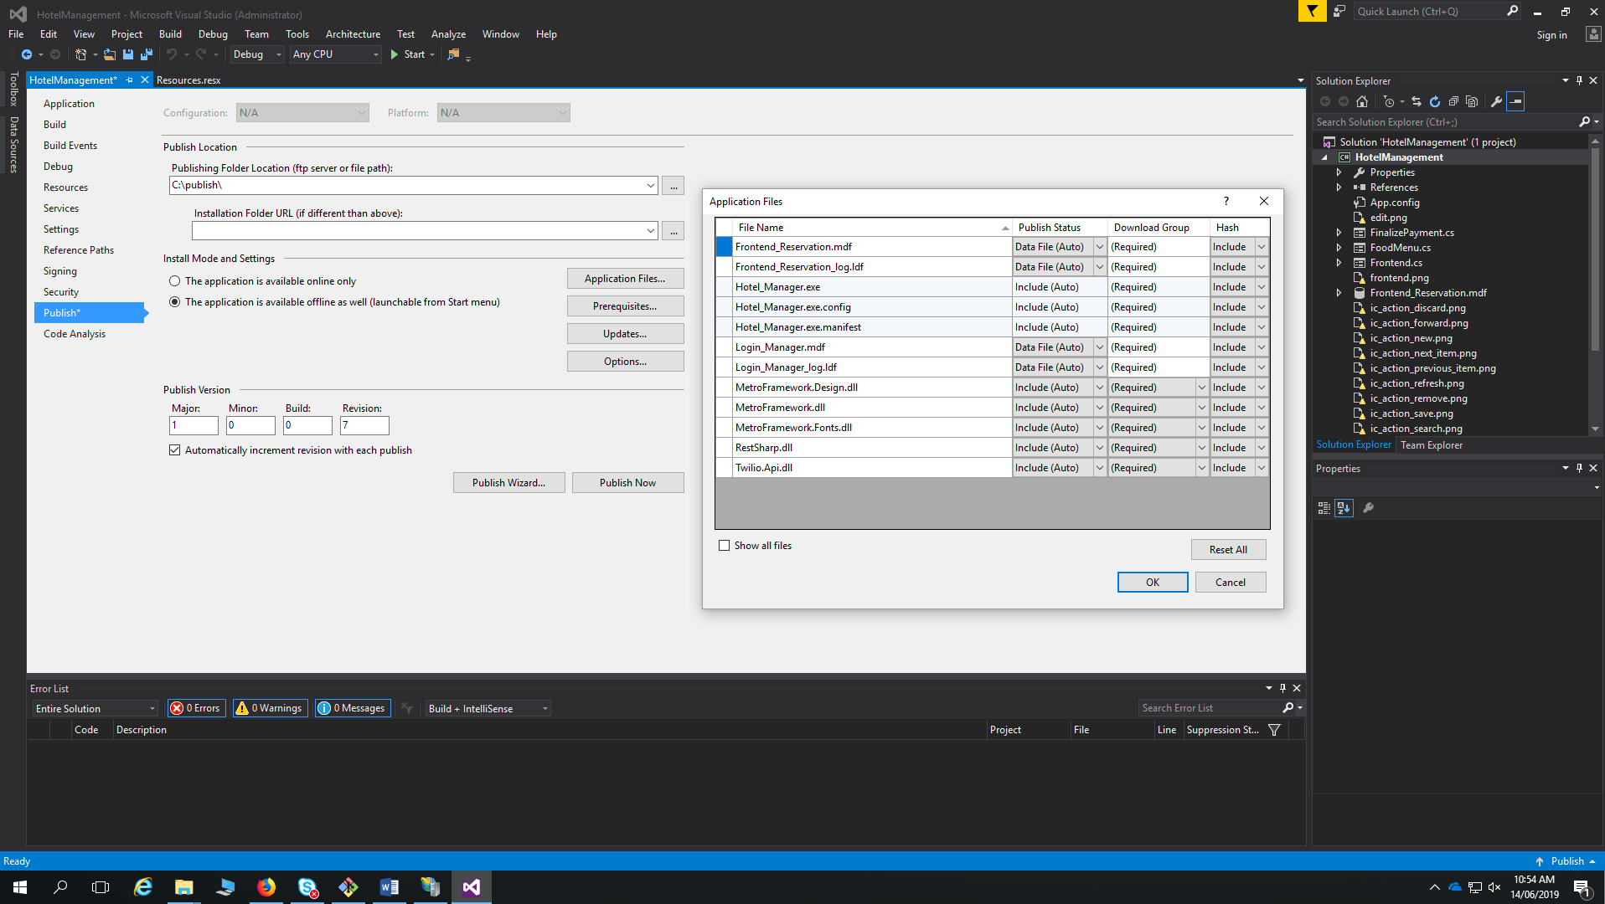

Figure : ClickOnce configuration to export .mdb files.

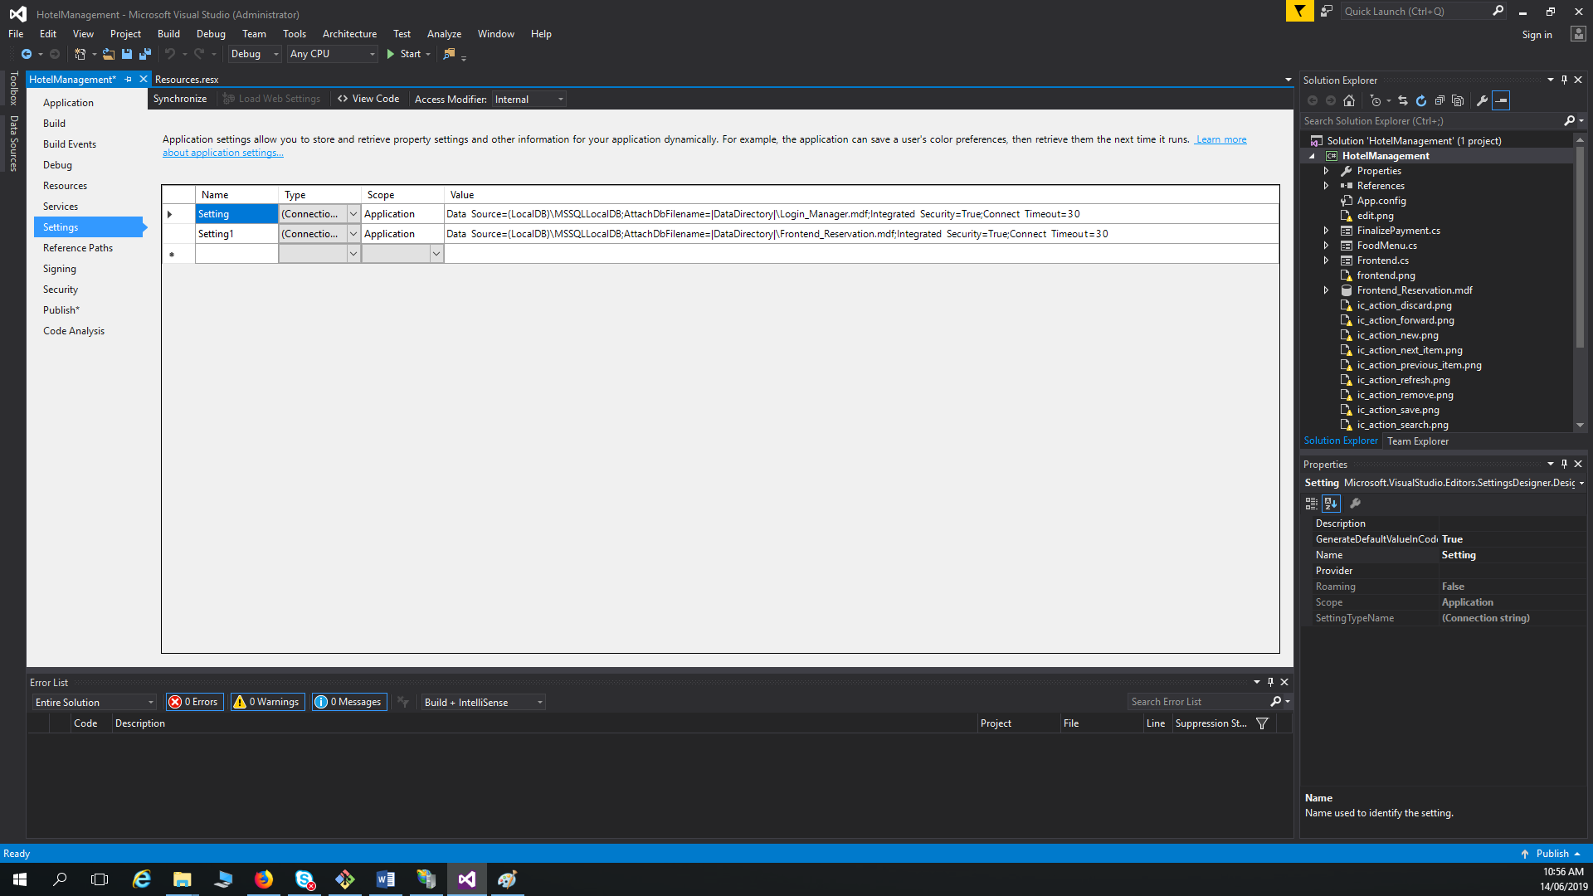

Figure : Connection strings configured in the app.config file.

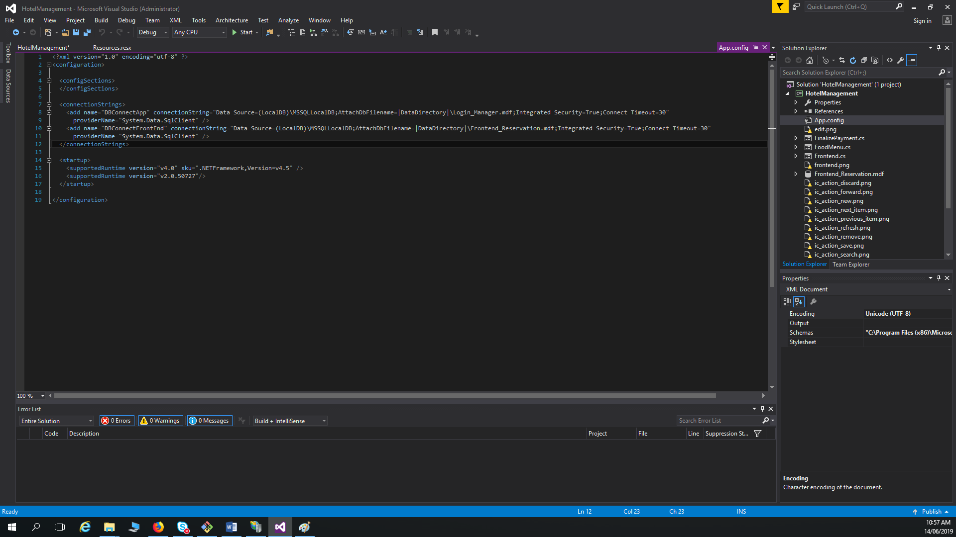

Figure : Configured settings in the app.config file.

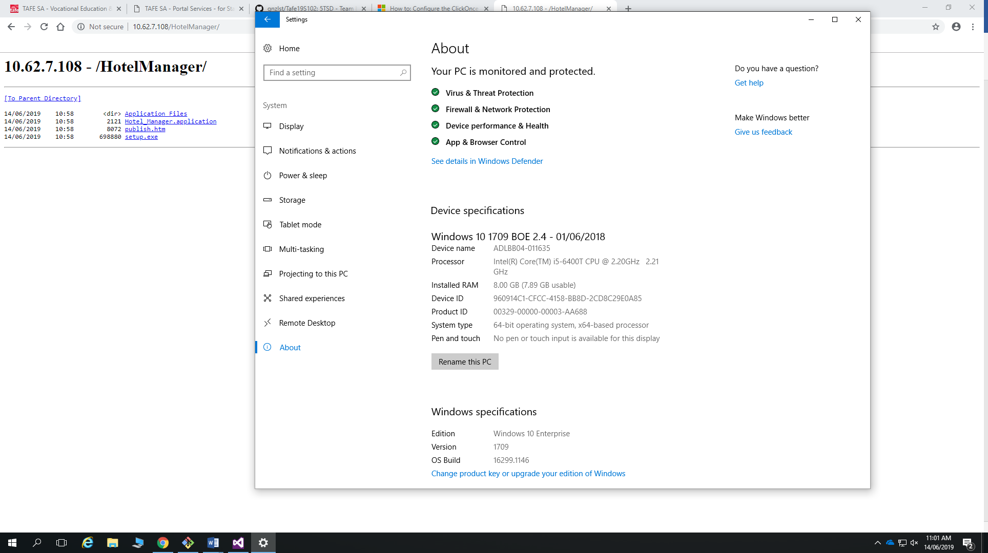

Figure : Navigating to installation package through IIS on client computer.

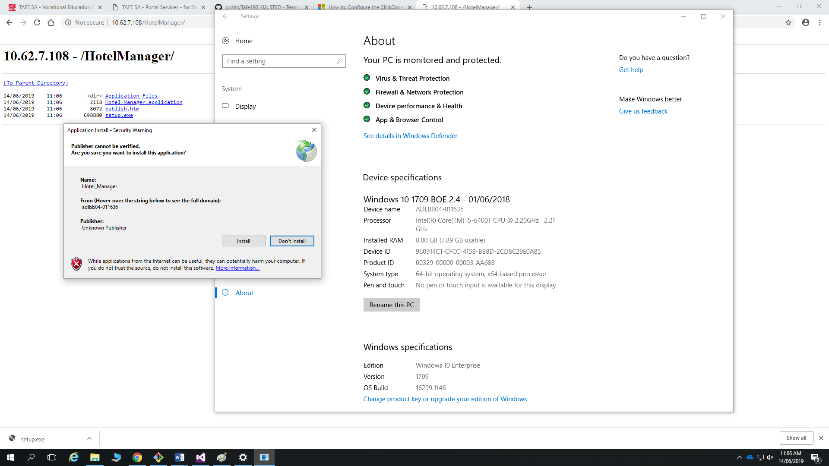

Figure : Installing package on client computer, prompted with security warning.

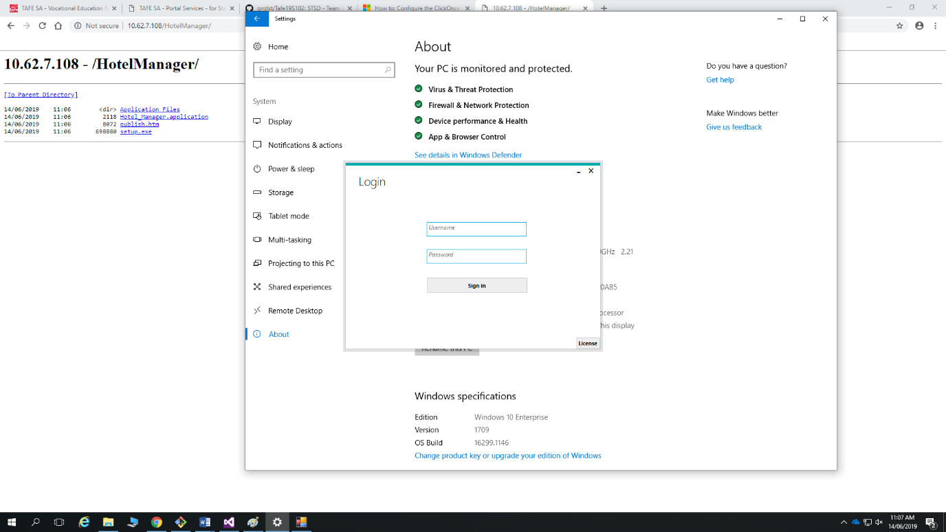

Figure : Starting application on client.

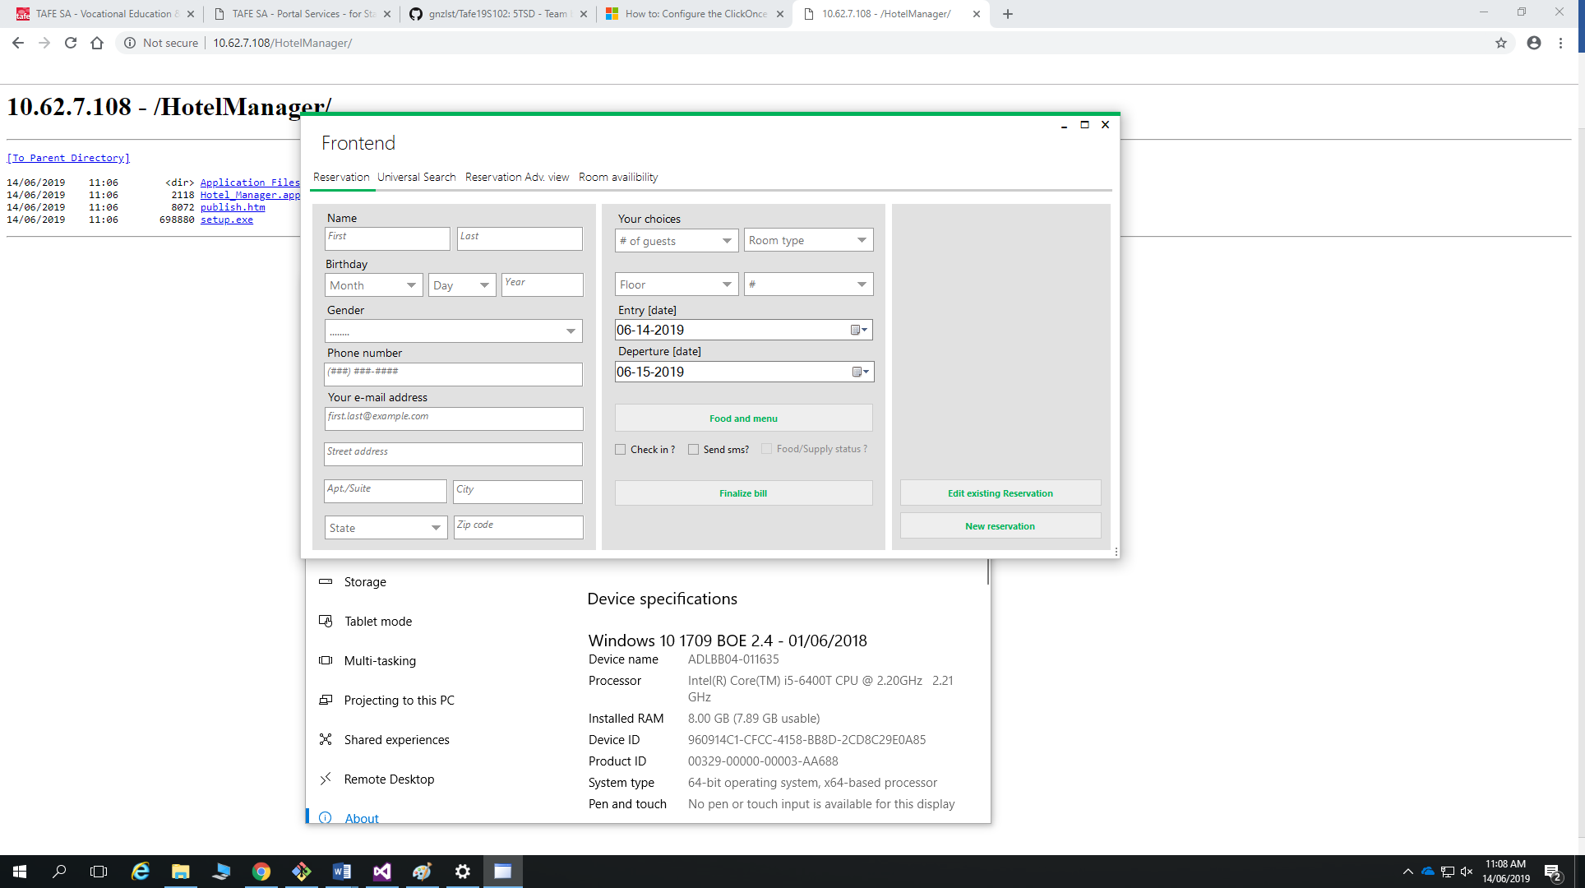

Figure : Main screen of application after logging on.

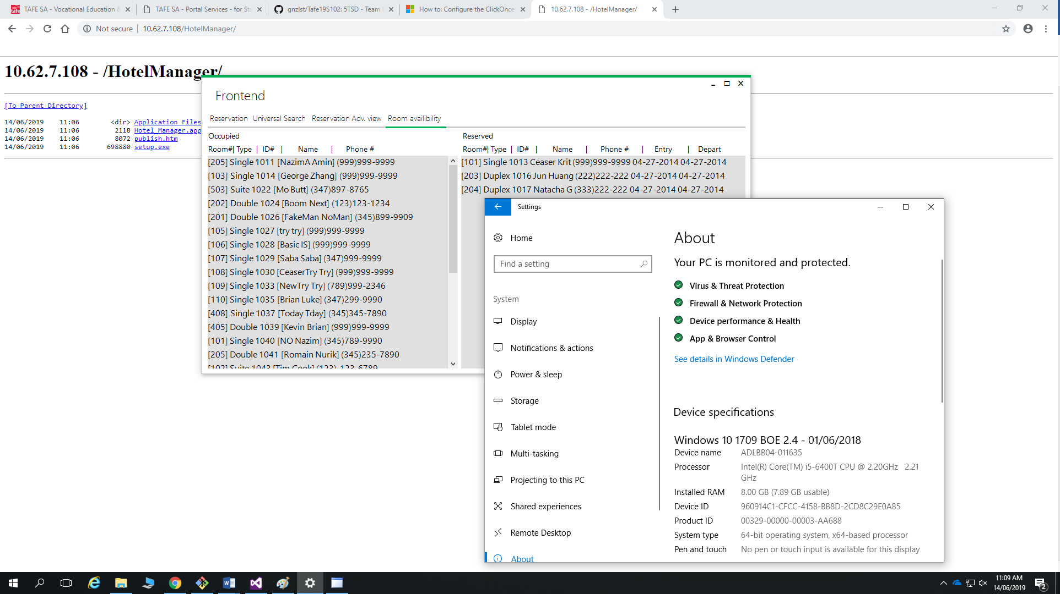

Figure : Application successfully linked to data source on client computer.

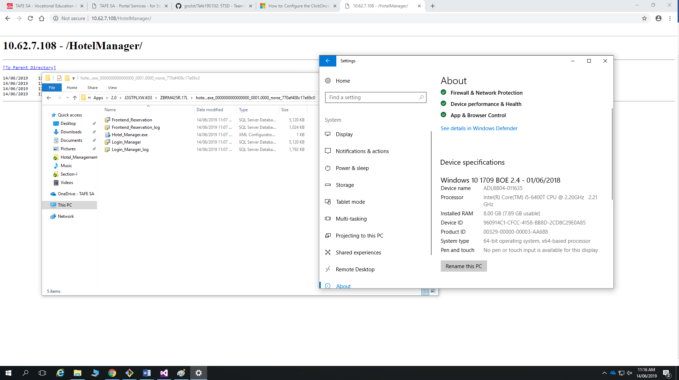

Figure : Data source located on client machine.

Part C:

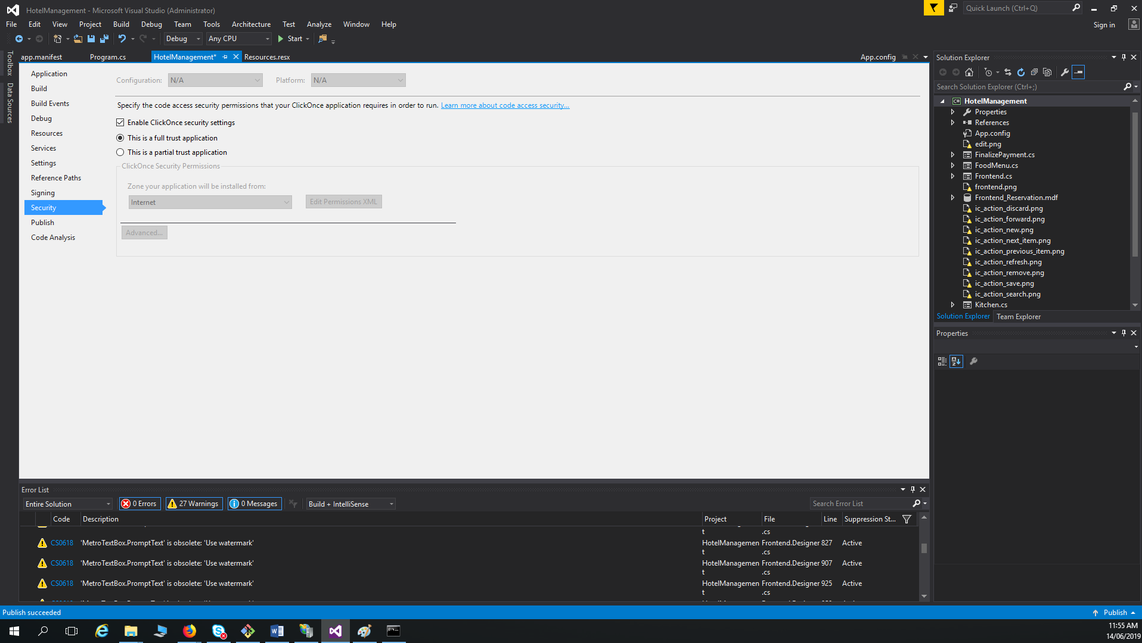

Figure : ClickOnce configuration for requesting higher level permissions on install.

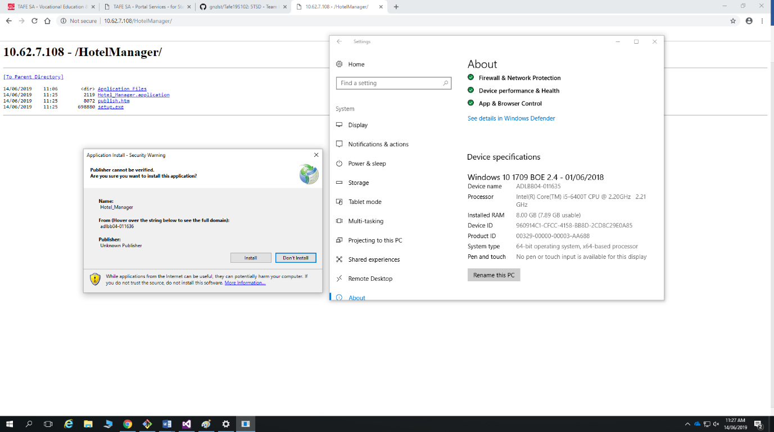

Figure : Client machine being prompted for elevated permissions on install.

**Merit point: (1 merit point will be given for the group)**

Demonstrate the final products to the lecturer. In the demonstration process, group members are able to describe clearly about:

* deployment strategy
* explain the difference of installing the application in the test machine and the production machine
* Explain the difference of installation between the windows, web and uwp platforms.
* Explain why some uninstallation packages do not clean all of the components and need manual deletion of files, folders & registry.